

Mathematics Specialist Unit 1

Test 1

Vectors

Name: ______________________ Total Marks:__________

Task type: Response

Time allowed for this task: 60 minutes, in-class, under test conditions
Section One: Calculator-free 25 minutes (23 marks)
Section Two: Calculator-assumed 35minutes (29 marks)

Materials required: Calculator with CAS capability (to be provided by the student)

Standard items: Pens (blue/black preferred), pencils (including coloured), sharpener, correction fluid/tape, eraser, ruler, highlighters

Special items: Drawing instruments, templates, notes on two unfolded sheets of
A4 paper, and up to three calculators approved for use in the WACE examinations

Marks available: marks

Task weighting: 4%

Section One : Calculator Free Marks 23
Time Allowed Reading 2 minutes
Working 23 minutes
Question 1 [1, 1, 1,2]
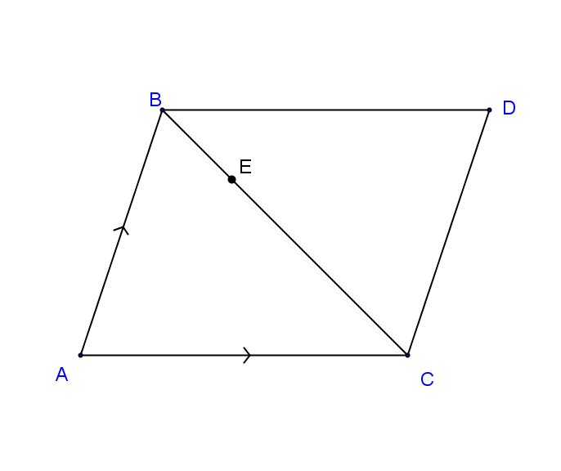

ABCD is a parallelogram with E a point on BC such that BE:EC = 1:3.
If $\vec{AC}= a$ and $\vec{AB}= b$. Express in terms of $a$ and $b$

- $\vec{DC}$

- $\vec{AD}$

- $\vec{BC}=$

- $\vec{DE}=$

Question 2 [3]

The vector $a=12i +5j$, Find the unit vector parallel to $a$ but in the opposite direction.

Question 3 [1,1,1,2,2]
Given $a=<2, 4>, b=<5, -1>and c= <-7,2>. Find$

- $a-b$

- $-2b$

- $3c$

- $4a-3b$

- $\left|a\right|+\left|c\right|$

Question 4 [2, 1, 1, 4]

Given than v = -3i +4j and u = 7i – j, find:
- |v + u|.

- The unit vector parallel to v + u.

- A vector that is parallel to v + u but with magnitude of 8.

- v in terms of s and t where s = -i -2j and t = -i + 8j.

Section Two : Calculator Assumed Mark 29
Time Allowed Reading 3 minutes
Working 32 minutes

Question 5 [5]

Vector $ai +bj$ is the same magnitude as $5i+12j$ and is in the same direction as $-2i+3j$.
Find the exact values of $a$and $b$.

Question 6 [3, 2]
A force of 45N is acting on an object in the direction of 220$°$.

- Write this force in component form where $i$ is a unit vector due east and $j$ is a unit vector due north.

- A second force acts on the object to keep it in a state of equilibrium. What is the magnitude and direction of this force?

Question 7 [6]

Adam leaves home and walks 2km on a bearing of 190$°$. He then travels 3.2km on a bearing of 070$°$. He then walks directly home from this point. How far will he have to walk home and on which bearing?

Question 8 [3, 3]
A boy intends to swim across a river of width 20 metres to the opposite bank. The river flows at a steady rate of 1 km/h. The boy can swim at a steady speed of 2 km/h.
•
- In what direction should the boy be headed so that he ends up at the opposite bank directly opposite to where he started off?

- Find the time taken for the swim in part a).

Question 9 [5,2]

Three forces act on an object in a flat plane. F₁ has a magnitude of 8 newtons and acts on a bearing of 070$°$, F₂ has a magnitude of 12 newtons and acts on a bearing 126$°$ and F₃ has a magnitude of 10 newtons and acts on a bearing 320$°$.

- Find the magnitude and the direction of the resultant force.

- Find the magnitude and direction of the single force that will keep the object in equilibrium.

